University of Rajshahi

Department of Computer Science and Engineering

B.Sc.Engg.Part-1 Odd Semester Examination 2015

Course: APEE 1131 (Electrical Circuit and Electronics)

Time: 3 Hours. Full Marks : 52.5

Answer any three questions from each part.

Part A

1. (a) State and explain Norton’s theorem.

(b) Stae and explain kirchoff’s voltage law.

(c) Find the current flowing through resister 20 Ω shown in the following Fig.1.

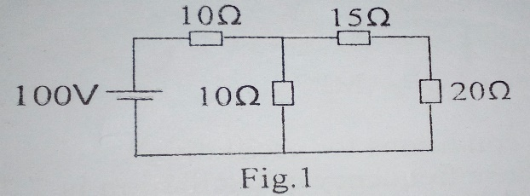

2. (a) What is semiconductor? Write the properties of semiconductor.

(b) What is P-N junction diode?

(c) Show that a Zener diode can be used as a voltage regulator.

3. (a) What is transistor? Discuss the structure of a transistor.

(b) How a transistor can be used as a switch? Explain

(c) Why is collector wider yhan emitter and base?

4. (a) What is filter?

(b) Deduce an expression for cut-off frequency of a high pass filter.

(c) Design a low pass filter having cut-off frequency 1 KHz and characteristics impedance 500 ohms.

Part B

5. (a) What do you mean by DC load line of transistor? What is Q point?

(b) For a single-stage CE amplifier circuit shown in following figure. Calculate i) rin ii) iii) A i iv) A v v)G p. Take transistor β=50. Neglect VBE and take re =0.5 V/IE.

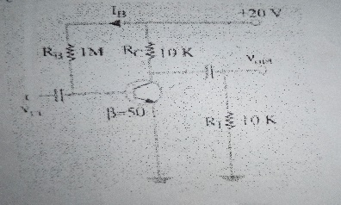

(c) Define α for a transistor.

6. (a) Define OP-AMP. What is the basic characteristics of an ideal OP-AMP?

(b) Derive the expression of voltage gain for different amplifier.

(c) A 5-mV, 1 KHz sinusoidal signal is applied to the input of an OP-AMP intergrator of Fig. 2 for which R1 =100K and CF= 1µF. Find the output voltage.

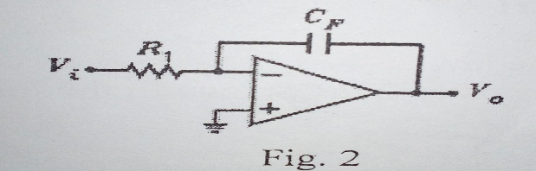

(d) What do you mean by virtual ground of OP-AMP?

7. (a) what is an oscillator? What are conditions for oscillation?

(b) Design an Astable Multivibrator whose frequency of oscillation is 7.25 KHz. Consider R1 =R2 and C1=C2

(c) what is feedback?

8. (a) what is mean by transistor biasing? Mention various method used for transistor biasing.

(b) what is advantage of potential divider biasing?

(c) Define cutoff point and saturation point.

(d) what is stabilization of operating point? what is the utility of ac load line?